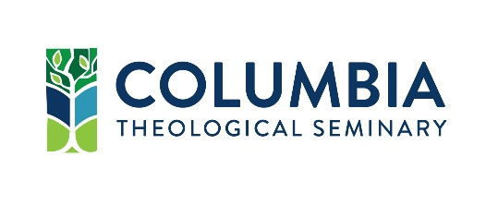

Temporary Student Associate for

Contextual Education and International Partnerships
Position Description

essential functions: The Temporary Student Associate(s) will provide administrative support for the Office of Contextual Education and International Partnerships and offer hospitality and information to students and other visitors. The Temporary Student Associate(s) will assist with digitization of paper files and may also spend some weekly work hours offering logistical support to International Students in partnership with Office of Student Affairs and Community Life. Additional work might include assistance with the Explorations program review, excel/database entry on supervised ministry placement sites, and website/design help. The Temporary Student Associate will report to the Interim Director of Contextual Education and International Partnerships.

desired qualifications:
- Experience living and working as an international student
- Familiarity with campus offices and processes
- Familiarity with Microsoft Office 365, especially word and excel
- Strong organizational skills
- Strong interpersonal skills
classification:
  - Part-time, 5-15 hours per week
  - Non-exempt
  - Term: March 2019 – June 2019

physical demands: Although physical limitations for this position can be accommodated, the job’s physical demands can include but are not limited to sitting, standing, stooping, crouching, bending, walking, and lifting light objects. Work is performed in an office.

disclaimer: The preceding job description has been designed to indicate the general nature and level of work performed by employees within this classification. It is not designed to contain or be interpreted as a comprehensive inventory of all duties, responsibilities, and qualifications required of employees to this job.

columbia theological seminary is an educational institution of the Presbyterian Church (USA), and a community of theological inquiry and formation committed to equity, diversity, and inclusion in the service of the Church of Jesus Christ. Established in the Reformed tradition, we embody an ecumenical spirit and welcome people of all denominational backgrounds.

